## horizontal line

Strengthy - Gym Web App

25-10-2023



Aditya Dutta

2110990088

B.E(CSE) 3rd Year(5th Sem)

G-28

# Overview

The Gym Web App is a comprehensive fitness-oriented web application developed using React, aimed at providing users with a versatile platform to enhance their fitness journey. This project was initiated to cater to the growing demand for online fitness resources and to offer users a seamless experience while obtaining fitness information, attending classes, and exploring fitness tips.

# Objectives

The primary objective of this project is to create a user-friendly and feature-rich web application that empowers users with the following capabilities:

1. Access to Fitness Information: Users can access detailed information about various exercises and fitness routines provided by experienced trainers.
2. Interactive Homepage: The application offers an engaging homepage with scroll-triggered animations, making the user experience visually appealing and interactive.
3. Subscription-Based Classes: Users can subscribe to fitness classes on a monthly or yearly basis, gaining access to live and on-demand fitness sessions.
4. Fitness Blogs: The web app provides the latest fitness tips and trends through a blog section, enabling users to stay informed about health and fitness.
5. Contact Us: Users can reach out to the gym's team for any queries, suggestions, or support via the "Contact Us" feature.

# Tech Used

Frontend: React, HTML, CSS, JavaScript

State Management: React Hooks

Routing: React Router

# Project Features

## Home Page With Scroll Animations

The application's home page is designed to captivate users with scroll-triggered animations. As users scroll through the page, they are greeted with visually appealing animations, making the website engaging and interactive.

## Exercise Information

The app offers comprehensive exercise information, allowing users to browse and learn about various exercises. Users can explore exercise descriptions, images, and video tutorials to understand and follow fitness routines correctly.

## Subscription-Based Classes

Users can purchase subscriptions for fitness classes, choosing between monthly and yearly options. Subscribers gain access to live and on-demand fitness classes led by experienced trainers. This feature allows users to exercise at their convenience, fitting their busy schedules.

## Fitness Blog

The web app maintains an up-to-date blog section that provides users with valuable fitness tips, nutritional advice, and the latest fitness trends. Users can stay informed about health and wellness through informative articles.

## Contact Us

In case of inquiries, feedback, or support requirements, users can easily reach out to the gym's team through the "Contact Us" feature. This ensures a smooth communication channel between users and the gym's administration.

# Interface

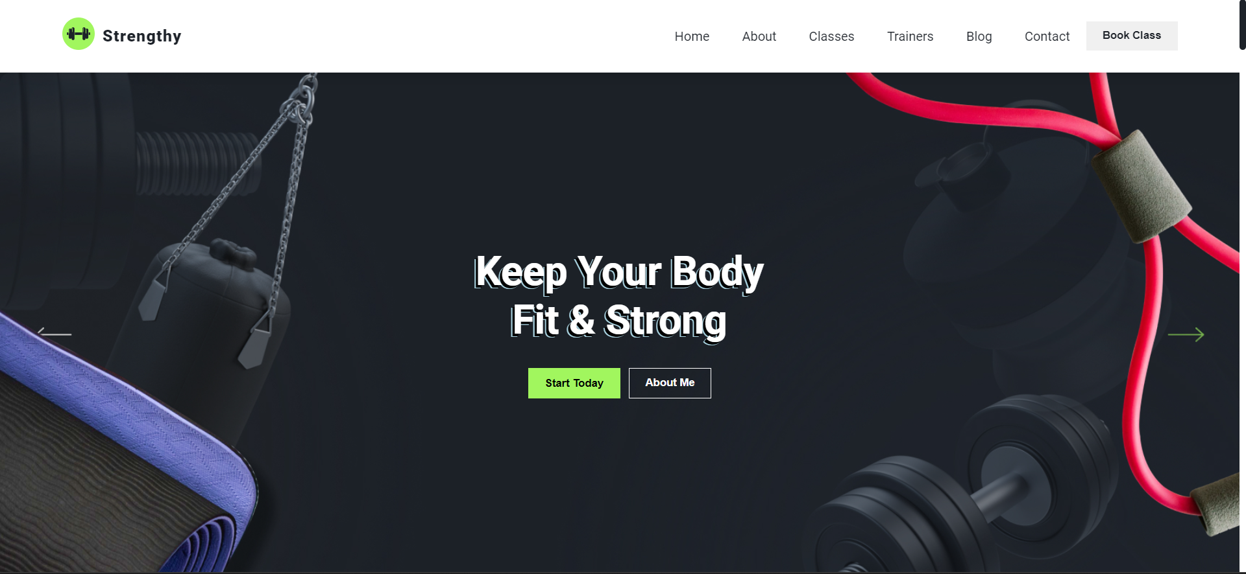

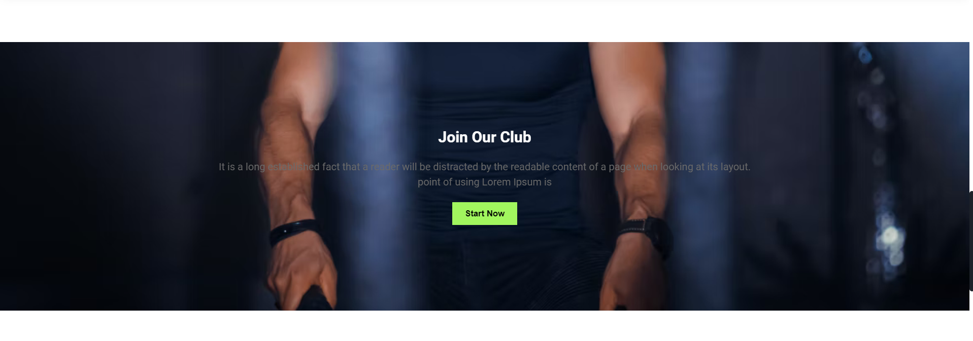

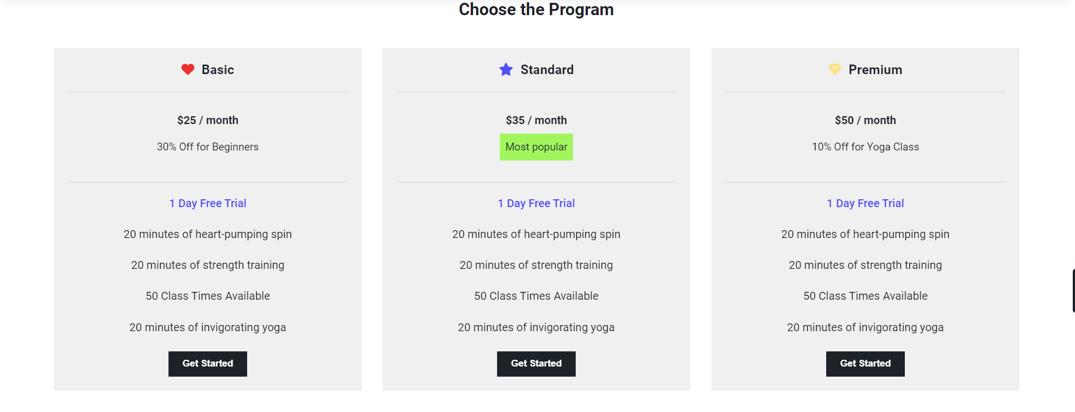

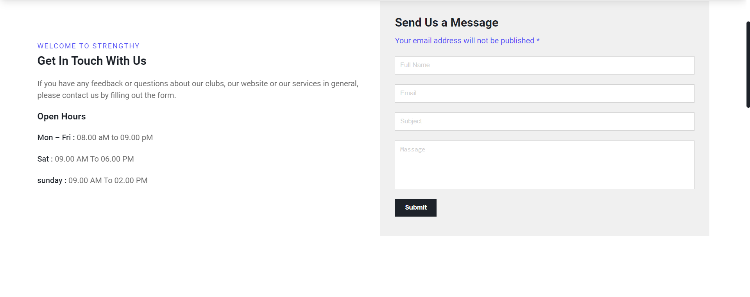

# Conclusion

The Gym Web App represents a significant step towards promoting fitness and health in a digital era. With its blend of engaging animations, exercise information, subscription-based classes, fitness blogs, and an accessible "Contact Us" feature, it caters to the diverse needs of fitness enthusiasts.

This project has successfully achieved its objective of creating a user-friendly and feature-rich application. It not only enhances the accessibility of fitness information but also offers the convenience of subscription-based fitness classes and a knowledge-sharing platform through fitness blogs. The "Contact Us" feature ensures user satisfaction by providing support and addressing queries promptly.

As health and fitness continue to be a focal point in modern society, the Gym Web App stands as a valuable resource for fitness enthusiasts, contributing to their overall well-being and promoting a healthier lifestyle.